Bradley Lamitie

Assigned 9/1/2016

Due 9/8/2016

Database Management Lab 1

1. PostgreSQL Page Admin tool screenshot:

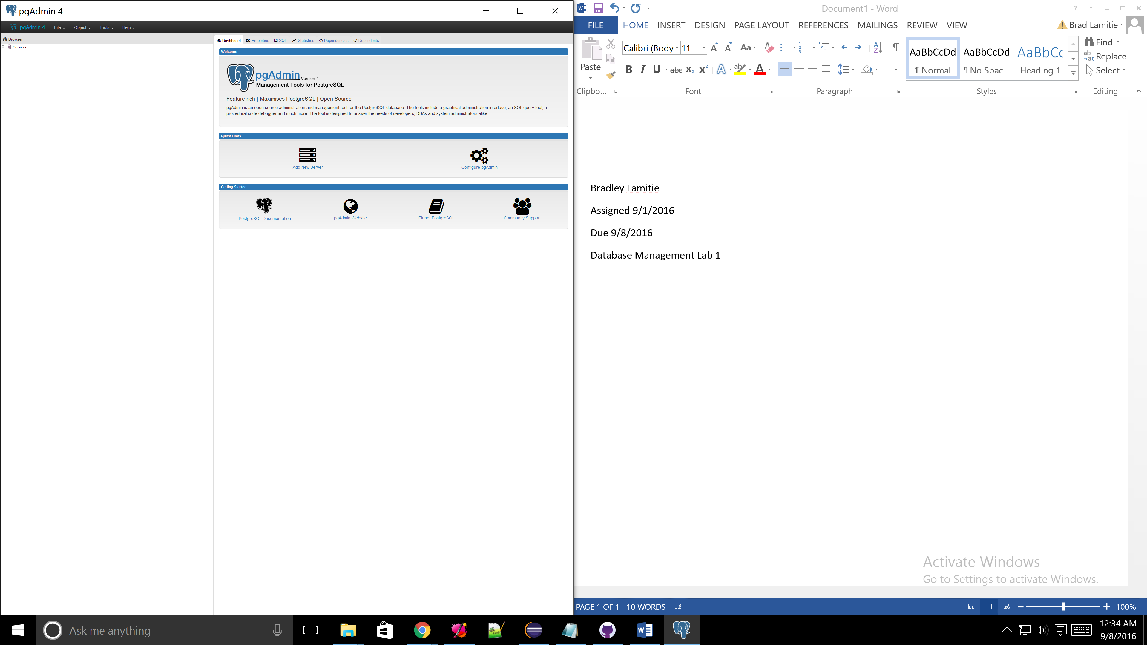

1. Netflix’ databases store data like; what show/movie a person watches, what genre that movie/show is, how long the viewer watched it before turning it off. Alone the data has some use. But Netflix uses this data to determine if a show is popular, if the user liked the show, and uses other data to suggest shows which the user may also like. For example if the user watches two violent movies like 300 and Gladiator, Netflix’s suggestion system will suggest a movie like another ancient war film, or Rocky. By simply knowing what show John Doe watches doesn’t do much for the company. But using that data along with what other shows he watches Netflix starts to profile John and decides what he might like more. The information this provides Netflix is what keeps its viewers hooked. They don’t have to worry about finding another movie somewhere else because Netflix has already lined up 50+ more shows for them to watch.
2. Hierarchical models are an abstraction of a database model. It uses root nodes that connect to branch and then leaf nodes. The issue with Hierarchical models is that there is no consistency between nodes. If a leaf node is updated in one place, that doesn’t mean it gets updated everywhere. The networking model is nearly identical but eliminates duplication. However compared to a relational database it still lacks the ability to use traffic control, and as a developer you can’t access the data without writing a separate program. As for XML I have to admit that it is much easier to tell what data belongs to each parent vertex. Although I feel that when there are a lot of different data points it may be harder to follow and search through using a program.